Free Youtube views for an unlimited number of your videos! Boost your video's popularity using their simple and free method! Or, buy Youtube views and other services here.

[ythunder.com](https://ythunder.com/) has free & open registrations.

[YouTube](https://ythunder.com/) rookies dream of having thousands to millions of views, but the struggle to how they can widen their reach to their audience is often an elusive attempt. Every [YouTuber](https://ythunder.com/) has a great desire to gain more views to increase income and gain more followers. Free Youtube views：[ythunder.com](https://ythunder.com/)

Have you ever asked yourself how wonderful and fulfilling it would be to see those numbers go through the ceiling? As much as you want it to be an instant thing, greatness is no small feat. So these questions hang in the air: *How can you gain more views on your* [*YouTube*](https://ythunder.com/) *video? What can you do to be garner more views?*

Here are some techniques to increase the number of views of your [YouTube](https://ythunder.com/) videos without doling a dime to any digital marketing schemes (though it might sound tempting!). The ways that we are about to tell you are very simple to follow, time-efficient, and will undoubtedly help you in the long run. We’ve come up with five brilliant tricks of the trade to gain the expansion of their audience entirely. Follow all these and see for yourself!

**Create a Channel Video Trailer to Make them Want More!**

The first rule of thumb is that a trailer will always spark the curiosity of the viewer, and it works all the time! Just imagine all the movies you have watched before, we bet your interest Free Youtube views：[ythunder.com](https://ythunder.com/)

surely started with a 60-second sneak peek. This can be your number one step to make your audience engage in your videos. This technique has been tried and tested by veteran [YouTube](https://ythunder.com/) uploaders, a short snippet captures the attention of the audience and stimulates their imagination.

Trailers are the ‘welcoming committee’ of videos that greets everyone to visit their Channel and browse through an array of your videos. All you need is a video clip that describes you, the Channel, and the purpose of your vlog. Time is of the essence when making the trailer. People generally have a short attention span so you should not give more than 60 seconds. A minute is the ideal duration of your trailer. It’s all you need, really so make every second count!

There will be endless search results about how to create trailer videos, and it will be a big help to you. You may also observe different [YouTuber](https://ythunder.com/)s on the different approaches they do on creating trailer videos. Mastery of creating persuasive videos will be a big bonus on your skills. It will eventually pay off as the number of views on your [YouTube](https://ythunder.com/) videos will significantly increase.

**Insert a Viewing Loop in Your Videos**

Have you ever noticed while watching videos on other [YouTube](https://ythunder.com/) channels, banners that suggest relevant videos from the Channel you were on suddenly pop up? These aren’t random banners appearing by chance. It is an advertising strategy that keeps your audience right where they are — which is your Channel, of course! It is one thing to gain views, but it is another when you gain subscribers. Loyal viewers will help you achieve consistency.

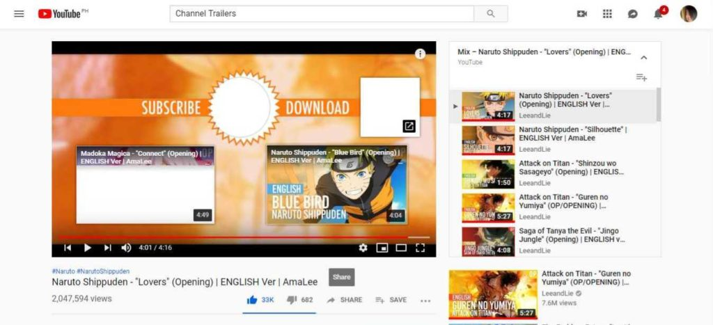

*Viewing loop of Amarlee after Lovers Song Cover. Screenshot was taken on August 24, 2022*

It is a sure-fire way to increase the volume of your supporters. Including a “Viewing Loop” feature into your videos will do wonders for your channel subscriber count. What exactly is a viewing loop? The viewing loop feature shows related videos from your Channel that would provoke viewers to stay glued to a string of your videos.

You can find a multitude of tutorial videos on how you can do the viewing loop feature, and it just takes a couple of minutes to do it. There are specifically two features that you can take advantage of: First, by adding in-video clickable links and second, by adding “Watch Next” videos. It only needs a few steps to manage it, and that little effort will make a massive difference.

**Sorting Videos to Playlists**

Categorizing your videos is a great way to be an organized [YouTube](https://ythunder.com/) channel. This step often goes unnoticed, but it is actually a big deal. People are a sucker for an organization, and while it might be a subconscious appreciation, it makes navigating a whole lot easier for the viewer. The Playlist feature will help the viewers for easy access as they source for videos to watch. By the time you gain loyal followers, these playlists will be a library that they can go back to when they want to reference your past vids.

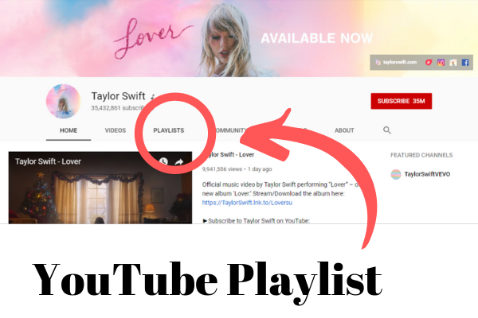

*Image: Taylor Swift’s* [*YouTube*](https://ythunder.com/) *Playlist. Screenshot was taken on August 24, 2022*

Titles featuring specific keywords of a playlist will surely help determine what those videos are all about. Writing a detailed description of every playlist will reinforce keywords. Doing this will leave no room for confusion, making the viewers want to stick around a bit longer. Also through this, you are now optimizing your Channel for SEO (Search Engine Optimization) purposes as a playlist appears in the search results. Your Channel or videos will be more discoverable with this feature.

**Linking Your** [**YouTube**](https://ythunder.com/) **Channel to Your Website**

Connecting your Channel with another website is a great way to increase your numbers. Linking your [Youtube](https://ythunder.com/) Channel to your website or blog post can build your brand and identity to the viewers. It may be used as a purpose for SEO (Search Engine Optimization) as it can fluctuate your Channel’s profile in the audience’s search engine. To be able to do this, under the “Channel” setting in the Advanced section, you may be able to include any website link you have with the essential keywords that will be filled in the Channel Keywords.

*Image: Yugatech linking their unboxing videos on their website. Screenshot was taken on August 24, 2022*

**Creating a Brand for Your Channel**

Competition is very tough in the [YouTube](https://ythunder.com/) world, as [Youtuber](https://ythunder.com/)s are competing for the same viewership space. In order to stay ahead, you gotta beat that competition.

The best way to win the competition is by creating a unique and relatable brand for your Channel. You can create your own brand just by building the identity of your Channel, making it appealing to the audiences.

These things will be a great deal on **how to create a brand** for you:

* Including a website and social media links
* Creating cover art featuring your brand and your Channel
* Convey messages that are easily relatable to the audience, most notably your target market
* Being creative in order to make viral content to gain views

The branding method will help viewers set you apart from other channels. Putting much thought into your brand personality will result in audience retention. If something comes up in their everyday lives and it reminds you of them, you know you’ve succeeded.

**These are the five easy, effective, and efficient ways to make your Channel and videos garner more views on** [**YouTube**](https://ythunder.com/)**. Of course, these tips are just a fraction of the ways you can learn to obtain views.**

**Bonus: More Ways for More Views**

* **Collaborate with other “**[**Youtuber**](https://ythunder.com/)**s” or “Vloggers**” with the same niche as yours. Reach out to other members of the community and grab the chance to partner up when you get a response. You may even have a chance to grab the attention of the other influencer’s following. This will open a window of potential subscribers!

*iJustine Collaboration with MKBHD on ibook unboxing*

* **Transcripts take a bit of time, but it will make a difference**. It can destroy the communication gap between you and other people who don’t understand the language you are using in your video. It would help you gain an international reach.

*Cyanide & Happiness with Transcript video*

Next

PreviousFree Youtube views for an unlimited number of your videos! Boost your video's popularity using their simple and free method! Or, buy Youtube views and other services here.

[ythunder.com](https://ythunder.com/) has free & open registrations.